**DAILY ONLINE ACTIVITIES SUMMARY**

|  |  |  |  |
| --- | --- | --- | --- |
| **Date:** | 16/06/2020 | **Name:** | Krishnitha |
| **Sem & Sec** | 4th sem, A Section | **USN:** | 4AL18CS039 |
| **Online Test Summary** | | | |
| **Subject** | Complex Analysis, Probability and Statistical Methods | | |
| **Max. Marks** | 30 | **Score** | 28 |
| **Certification Course Summary** | | | |
| **Course** | Application Developer | | |
| **Certificate Provider** | AWS Educate | **Duration:** | 3 hrs |
| **Coding Challenges** | | | |
| **Problem Statement:**  Write a Java program to check whether a given a binary tree is a valid binary search tree (BST) or not? | | | |
| **Status:** Executed | | | |
| **Uploaded the report in GitHub** | | YES | |
| **If yes Repository name** | | <https://github.com/krishnitha/Java-coding> | |
| **Uploaded the report in slack** | | YES | |

**ONLINE TEST DETAILS:**

Today we had assessment in the subject Complex Analysis, Probability and Statistical Methods. The test was conducted on the first module of this subject. The test comprised of total 15 questions of TWO marks each, out of which I scored 28.

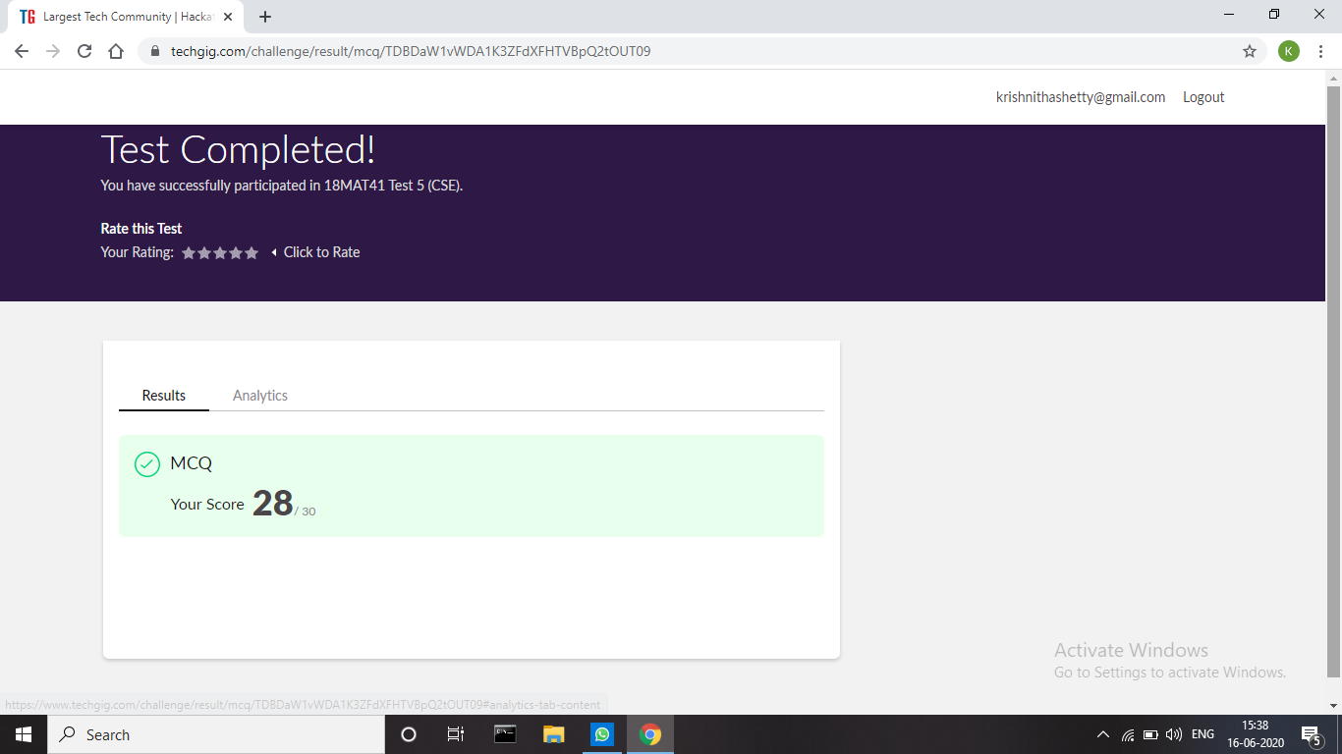

**Certification Course Details:**

Today I have continued the course “Application Developer” by AWS Educate. In this course today I learnt about ‘Software Development: Web, Mobile and Gaming’. In this module I learnt about web development and Mobiles for start-up’s and Gaming. I have also successfully completed the Assessment regarding this module.

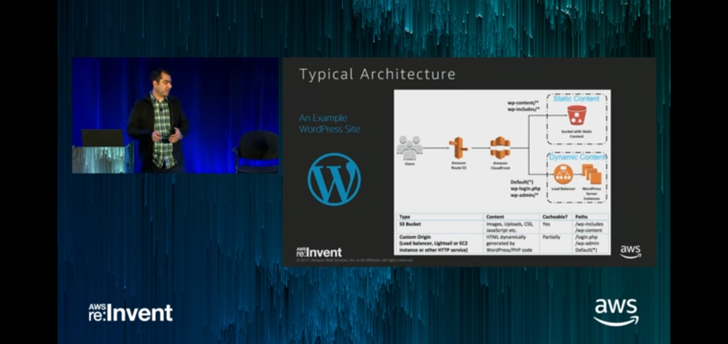

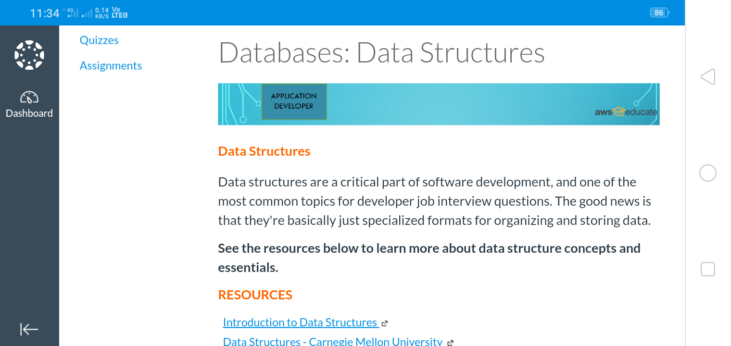

**Coding Challenges Details:**

**Problem:** Write a Java program to check whether a given a binary tree is a valid binary search tree (BST) or not?

**Solution:** Uploaded it in GitHub

